Progress Report
Sensor-Assessed Clinic versus Home Gait Measures in At-Fall Risk Older Adults
Neil B. Alexander¹, Lauro Ojeda², Xun Huan²
¹Department of Internal Medicine, Division of Geriatric and Palliative Medicine, VA Ann Arbor Healthcare System Geriatric Research Education Clinical Center, ²Mechanical Engineering, College of Engineering
Specific Aims:
The overarching goal of the proposed NIMLAS pilot is to compare on-site (on-site) versus home gait measures using this single IMU collection and analytic approach, validate any differences that might relate to balance impairment, and explore these relationships during real world daily activity in an at-fall risk older adult cohort with varying balance impairment. In older adults (n=20) at risk for falls and with varying standing balance impairment, we aim to:
Aim 1: Compare at-home versus on-site (Mobility Research Center) differences in key gait measures during a two-minute walk (2MW) test.
Hypothesis 1: The majority of 2MW gait measures will differ, particularly those related to speed, with slowing at-home versus on-site.
Aim 2: During the 2MW, determine how different underlying levels of balance impairment affect on-site versus at-home gait measures.
Hypothesis 2: At-home (versus on-site) slowing will be disproportionately greater in those with greater balance impairment.
Aim 3: Use machine learning methods to analyze variability in gait measures over a three day measurement period to predict levels of balance impairment.
Hypothesis 3: A machine learning model using gait measures can be trained to predict balance impairment with high accuracy.

1. What major activities have been accomplished, under each of your specific aims, with your pilot project funding?
We recruited 26 older adults (23 males, 3 females) from an Ann Arbor VA exercise program (Gerofit), mean (SD) age 73.4 (6.1), to complete a protocol of both clinical (on-site) mobility testing and at home, both with and without to use of wearable sensors (inertial measurement units, IMUs) affixed to the top of the shoe (APDM Wearable Technologies, a Clario Company, Philadelphia, PA; 128Hz, ±16/200G, ±2000 deg/s). The protocol without the sensor was designed to test the balance and gait of participants on a series of well-accepted standard tools used in aging research: 1) Short Portable Performance Battery (SPPB), including a series of standing balance, multiple timed rises from a chair, and normal gait speed; 2) Timed unipedal stance, the ability to hold the left and right leg off the floor for up to 10 seconds; and 3) usual gait speed over 10 feet. An additional task was a 2 minute walk in a hallway. These mobility tasks were performed on-site at the Ann Arbor VA and also at home, the latter via a video telehealth link with the research associate providing instructions and using a stopwatch to do all timing.
For the sensor analyses, IMU raw data were used to extract footfall events and spatial foot placement directly from sensor measurements. Our approach leverages linear accelerations and angular velocities to estimate stride timing and position without external references. Orientation was estimated by integrating gyroscope data; accelerations were transformed into the global frame to reconstruct foot trajectories for each gait cycle. Foot contact was detected using characteristic signal patterns, enabling precise segmentation of strides into stance and swing phases by identifying periods of low dynamics. During stance phases, zero-velocity updates were applied to mitigate integration drift.
To identify and remove turning segments, step-to-step heading changes were calculated and smoothed with a moving average. Steps in which the change in heading exceeded a 25-degree threshold were classified as turns, while the remainder defined straight walking segments. Step lengths and speeds in straight segments were computed based on the Euclidean distance and associated stride timing. Only steps within the identified straight segments and walking window were analyzed. Final stride length and speed metrics were averaged across left and right foot data, quantifying walking performance for each trial.
Using these processed gait features, we measured the total distance traveled during the 2-minute walk, as well as individual step lengths and speeds specifically within straight walking segments. Statistical analyses of these outcomes are presented the analytics section of this report.
We then developed a set of machine learning analytics to characterize gait variability and coordination patterns. These methods operate directly on multichannel bilateral foot time-series data and are designed to extract clinically meaningful structure even when labeled impairment outcomes are limited. Two complementary analytic strategies were implemented. First, an unsupervised feature-analysis pipeline summarizes gait dynamics (e.g., cadence variability, step timing, turning behavior) and compares home versus clinic measurements using dimensionality reduction and clustering. This approach identifies participant subgroups based on patterns of environmental sensitivity without requiring predefined labels. Second, we developed a self-supervised learning framework that models inter-limb coordination directly from raw time-series signals. The model learns to predict masked segments of one foot’s motion from the other foot’s signal, yielding a quantitative coordination score that reflects consistency and predictability of bilateral gait. This score is interpretable and can reflect irregular steps, noise, or reduced coordination.
Project modifications:
1) A key modification from the original paradigm is that participants performed these tasks at home while being instructed and observed via an audiovisual telehealth connection.
2) For the proposed protocol, one IMU streaming device was initially used with a Bluetooth connection to a cell phone. This was abandoned after the first 10 participants because of: 1) the participant burden of reliably carrying the cell phone; 2) synchronizing the IMU device reliably to the phone; and 3) other reviews from other grant submissions that considered use of a single IMU a key flaw and limiting the potential data acquired.
3) Analysis of gait variability using the sensor data was limited due to the limited number of straight line steps taken. Accordingly, the distance measure thus includes all turns whereas the step length and speed do not.
Project progress:
While 26 participants were recruited and baseline tested as above, the first ten participants used a single IMU device. An additional five had incomplete sensor data from either on-site or in home testing due to technical issues. Accordingly, we have on-site and home data on 26 participants without sensors, and 13 with two IMU data loggers.
Aims 1 and 2 analytics
For those with complete sensor data on-site and at home (n=13), the 2 minute walk measures (distance, step length, and step speed) were modestly consistent between on-site and in-home testing. Compared to on-site measures, home measures were reduced from 7-9%. For the key 2 minute walk measure, this difference was not statistically significant (See Table 1). Key balance and gait measures such as impaired one legged stance time (< 10 seconds on both legs) and slowed gait speed (<1.0 m/s) did not predict either on-site, home, or the difference measures.
A surprising but consistent finding was the marked reduction in gait speed acquired (non-sensor) during the 10 foot walk at home compared to on-site in the sensor group, averaging 45% reduction (p<0.001). More importantly, the mean reduction was 0.35 m/s, which is considered clinically significant. There also was wide variability in performance. This was also found in the non-sensor group, with a 32% difference (p<0.001) and a clinically significant difference of 0.3 m/s. Again, there was no impaired one legged stance effect.
For those in the sensor group with 10% or greater differences between the on-site and home in 2 minute walk distance, a number of issues were noted by the assessor. Based on the video record, some environmental demand was higher, including needing to navigate loose rugs, items hung on the walls of the walkway, and a reduced walkway course, thereby creating more turns. In one case, the participant had returned from exercise class and admitted to fatigue.
In summary, there were small but not statistically (or clinically) significant differences in the 2 minute walk measures between on-site and at home testing. The shorter 10 foot walk surprisingly showed more sizeable differences in certain cases , and were at least partly explained by the environment demand noted on the video record. We conclude that future testing at home must consider not just careful patient instruction but also how the patient is able to address their home environment demand to optimize valid testing outcomes.
Table 1. Mean (SD) Mobility Task (No Sensor) and 2 Minute Walk Sensor Data for Sensor Cohort (n=13)
 | On-site | Home | % Difference
Mobility (no sensor)
10 ft Walk speed (m/s) | 1.2 (0.3) | 0.9 (0.2) | -45 (33)
Chair stands (#/30 s) | 17.1 (5.9) | 16.4 (4.5) | -2.3 (11.4)
SPPB score (0-12)* | 11.5 (0.5) | 11.2 (1.0) | -2.0 (8.3)
Sensor (2 minute walk)
Distance (ft) | 124 (17) | 113 (21) | -9.3 (11)
Step length (in) | 1.2 (0.2) | 1.1 (0.2) | -8.5 (9)
Step speed (sec) | 1.2 (0.2) | 1.1 (0.2) | -6.8 (11)

Table 2. Mean (SD) Mobility Task (No Sensor) for Entire Cohort (n=26)
 | On-site | Home | % Difference
Mobility (no sensor)
10 ft Walk speed (m/s) | 1.2 (0.2) | 0.9 (0.2) | -32 (32)
Chair stands (#/30 s) | 18 (4.7) | 17 (4.2) | -3.4 (13)
SPPB score (0-12)* | 11 (0.1) | 11 (0.1) | -0.3 (6.5)

*SPPB score is a total of balance tasks, chair stands, and gait speed, scored according to quintiles, with the sum score of these domains ranging from 0-12.
Aim 3 analytics
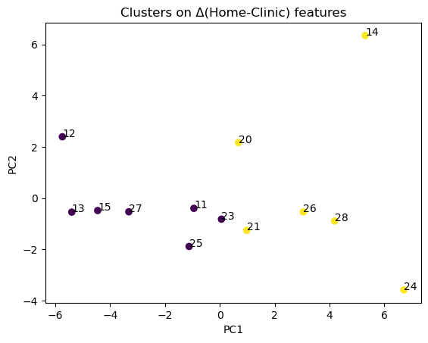
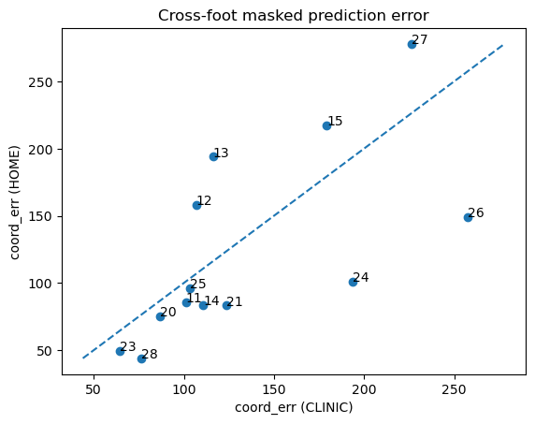
Preliminary machine learning analyses demonstrate that wearable sensor-derived gait features contain structure that distinguishes participant mobility patterns across environments. In an unsupervised analysis, principal component analysis (PCA) was applied to summary statistics derived from bilateral IMU time series, followed by k-means clustering. As shown in Figure 1, participants form separable groupings in the low-dimensional feature space defined by the first two principal components, indicating that home-clinic gait differences contain systematic variation rather than random noise. These clusters reflect distinct patterns of environmental sensitivity in gait behavior and suggest that latent mobility phenotypes can be identified directly from sensor data without requiring labeled outcomes.
Figure 2: Principal component projection of home-clinic difference features derived from bilateral foot IMU time-series summary statistics. Each point represents a participant, plotted in the space of the first two principal components. K-means clustering reveals separable group structure, indicating that patterns of gait change between environments contain systematic variation that can distinguish participant mobility profiles.
Figure 1: Cross-foot masked reconstruction error as a self-supervised coordination metric. Each point shows a participant’s coordination error computed from clinic versus home trials. The dashed line denotes equality between environments. Lower error indicates more predictable bilateral gait dynamics and stronger inter-limb coordination, while higher error reflects increased irregularity or reduced coordination.
Complementing this feature-based approach, we developed a self-supervised learning method that quantifies inter-limb coordination directly from raw signals. Each 2-minute walk recording is segmented into short temporal windows, and within each window portions of the left and right foot signals are randomly masked. The model is trained to reconstruct the missing segments using contextual information from both limbs. As illustrated in Figure 2, the resulting reconstruction error provides a coordination score: smaller errors indicate more predictable, regular bilateral gait dynamics, whereas larger errors indicate weaker coordination or irregular stepping patterns. This metric can be computed for each participant and environment, enabling comparison of coordination consistency between clinic and home conditions.
These analyses establish that (1) unsupervised feature representations can stratify participants according to patterns of gait change, and (2) self-supervised coordination metrics provide a continuous quantitative descriptor of gait stability. These complementary outputs form the analytic basis for subsequent Aim 3 modeling that will link sensor-derived metrics to clinical balance impairment once outcome labels are incorporated.
Preliminary Aim 3 analyses indicate that machine learning methods applied to wearable sensor gait data can uncover structured mobility patterns and quantify inter-limb coordination without labeled outcomes, supporting the feasibility of predicting balance impairment from real-world movement signals.
2. How have lessons learned / research findings / analysis results from each of your specific aims been disseminated to the broader community of longitudinal researchers that might benefit from what you have learned?
Not yet. Hope to put abstracts together shortly.
3. Please provide formal citations for all conference presentations, technical reports, journal articles, or data sets arising from your work. Submitted abstracts, papers, or reports that are under review should also be included.
Sorry, none yet directly from these data.

